**Massachusetts Bays Program**

**Quantitative Estuary Assessment**

**EDA 2.0**

**April 1, 2018**

**Summary Statement**

Coastal ecosystems are among the most valuable on earth because of the ecosystem services they provide, but also are highly vulnerable to degradation. Thus, coastal embayments and the valuable, imperiled habitats within them are the focus of conservation and restoration efforts throughout the U.S. In many coastal regions, understanding of stressor levels and resource quantity and quality is limited, which hampers conservation and restoration efforts. Thus, defining existing levels of both anthropogenic stressors and key ecosystem resources will enhance efforts to conserve and restore coastal ecosystems so that they continue to deliver valuable ecosystem services. In this study, we evaluated the stressor and resource attributes of the MassBays National Estuarine Program (NEP) region in coastal northern Massachusetts. In particular, we conducted principle component analyses (PCA) and partitioning around mediods (PAM) to identify clusters of MassBays embayments with similar resource and stressor attribute levels (Objective 1). Next, we conducted similarity percentages (SIMPER) analyses to examine which resource and stressor attributes differed between pairs of Clusters. We then used these results to propose potential target stressor and resource levels for each embayment (Objective 2). This second objective also included regression tree analyses aimed at identifying the stressor attribute(s) that were the strongest predictors of resource attribute levels within embayments.

Our PCA and PAM analyses in Objective 2 identified 4 clusters of embayments in the MassBays region. Not surprisingly, embayments in the greater Boston area collectively formed a single cluster, which is likely a consequence of high stressor attribute levels, such as high population density, land change/land use, and shoreline hardening, which collectively could explain why this cluster had relatively low resource levels. Unlike this cluster centered around Boston, the other three contained embayments scattered across the entire MassBays region. This finding suggests that geography alone is a poor predictor of stressor and resource levels in the MassBays region.

Our results provide insight into resource and attribute levels that may be achievable within a cluster. For example, our results provide a potential realistic target for the lower bounds of stressors and upper bounds of resources that might be achievable for embayments within a given cluster. We discuss a wide range of methods to set target: the lower bound of the range is the current lowest level within a cluster, and likely is the minimum level achievable for each stressor attribute. Because reducing levels to the lower bound within a cluster may be unrealistic given the range of competing demands within an embayment, the mean or median may be a more realistic target. These same considerations are true for setting targets for resource attributes (i.e., whether to go with somewhere near or at the upper bound vs. the median or mode). Given that several stressors may individually or interactively be contributing to declines in a resource attribute, achieving targets for resource metrics may be even more challenging.

Our analyses also suggested that salt marsh habitat is apparently vulnerable to a variety of stressor attributes. Shoreline hardening, which is common in highly urbanized areas such as Cluster 4, is a strong predictor of reduced levels of salt marsh habitat, which is supported by past empirical and review studies. In this study, we determined that 20% of shoreline hardened appears to be a critical threshold, above which both salt marsh shoreline and salt marsh extent decline precipitously. In addition to shoreline hardening, high population densities corresponded with lower levels of salt marsh extent. Meanwhile, in areas with low levels of shoreline hardening, septic system use was an important predictor of salt marsh shoreline loss. Collectively, these results indicate the stressors that are most likely responsible for degradation of salt marsh habitat, along with critical thresholds that could serve as effective targets for embayments experiencing higher levels of these critical stressors. Regression tree analyses of the potential drivers of differences in tidal flat and seagrass levels did not reveal any stressors that were strong predictors. The failure of regression tree analysis to identify critical thresholds of potential predictors seagrass could be a consequence of several factors discussed below. As mentioned above, results from Objective 1 provide potential levels (e.g., the lower bound, the mean) that could be used to set targets for stressor attributes.

While the analyses in this study were possible because of the vast array of data on stressor and resource attributes collected by resource agencies in Massachusetts, we suggest additional metrics that would potentially benefit future analyses. Some of these variables would enhance our understanding of potential stressor metrics already included in our analysis, such as levels of specific nutrients (e.g. phosphorous, ammonia), the volume of septic waste discharges, or the severity of tidal restriction within each embayment. Others, such as invasive species, subsidence, livestock density, levels of pollutants in waterways (e.g. halogenated hydrocarbons, polycyclic aromatic hydrocarbons, heavy metals), and bottom area dredged, represent novel metrics that could be valuable in better characterizing the suite of stressors facing each embayment. Inclusion of these different sets of stressor attributes could help identify potential predictors for resource attributes such as seagrass and tidal flat habitat. Similarly, future analyses would benefit from considering both additional resource attributes (Table 15) and from supplementing existing datasets with more robust sampling. For instance, shellfish habitat is known for providing a vast array of ecosystem services, such as filtering the water and providing nursery grounds for juvenile fish and crustaceans. Kelp and rocky intertidal and subtidal habitat also are valued for the ecosystem services they provide. Thus, efforts to characterize these resource attributes would be valuable to future MassBays assessments.

**Introduction**

Coastal and estuarine ecosystems are among the most valuable on earth because they provide disproportionately large amounts of ecosystem services (Costanza *et al.*, 1997; Barbier *et al.*, 2011). For instance, seagrass, salt marsh and oyster reefs, all critical habitat with coastal estuaries, provide nursery and foraging grounds for fishes, cycle and remove excess nutrients, and stabilize shoreline sediments, to name a few. Human societies have benefited from and exploited this vast array of culturally and economically valuable services over the past millennia (Beck *et al.*, 2001; Jackson *et al.*, 2001), with almost half of the world’s population currently living at or near the coast. Unfortunately, human development and activities have also greatly degraded these coastal ecosystems that they are reliant upon (Halpern *et al.*, 2008; Barbier *et al.*, 2011). From overharvesting to eutrophication, dredging, and release of invasive species, coastal and estuarine ecosystems face multiple stressors. As a result, critical estuarine and coastal habitats such as coral reefs, oyster reefs, mangroves, seagrass beds and salt marshes have been reduced by 20-85% globally (Lotze *et al.*, 2006; Airoldi & Beck, 2007; Wilkinson, 2008; Waycott *et al.*, 2009; Beck *et al.*, 2011; Grabowski *et al.*, 2012), with some regional estimates suggesting even more severe degradation levels (Rothschild *et al.*, 1994; Kirby, 2004). The net result of this habitat degradation is the loss of valuable ecosystem services that human societies rely on.

A crucial first step in implementing regional conservation efforts involves assessing and analyzing both the ecological components of ecosystems, such as the quantity and quality of essential habitats, and the anthropogenic stressors that these systems face. Efforts to conserve and restore these valuable, but degraded, habitats and other coastal resources will be limited without this critical baseline information. As such, regional conservation efforts may benefit from clustering local embayments with similar resource and stressor attributes to reveal more achievable targets for each embayment. For instance, more urbanized embayments will likely have very different stressor and resource levels than those of rural areas. Importantly, particularly in highly urbanized areas, many of these stressors have limited scope to be reduced (e.g., population density or land use/land cover), while reductions in others may be more readily achieved (e.g., stormwater runoff and waterbody impairment for bacteria/nutrients). Yet, defining existing levels of both anthropogenic stressors and key ecosystem resources is an essential first step towards enhancing the ability of coastal resource managers to conserve and restore critical coastal embayments and the resources that they provide. Here, we apply this approach to the MassBays National Estuarine Program (NEP) region in coastal northern Massachusetts.

The MassBays region spans from the Massachusetts/New Hampshire border through Cape Cod, and is divided into estuarine and coastal embayments. Given the variety of resources and management concerns across the MassBays planning area, it is important to recognize the differences among, and uniqueness of, all of its embayments. The different geomorphological settings of the embayments create diverse ecological and socioeconomic characteristics which in turn result in specific management needs. With the recent revision of the Comprehensive Conservation and Management Plan (CCMP), MassBays seeks to focus more of its efforts on addressing priority needs and changing ecosystem conditions at the embayment level. To support this more locally targeted effort, we conducted a series of analyses to characterize and develop clusters of MassBays embayments with similar resource and stressor attribute levels (Objective 1). We then identified target conditions for each embayment (Objective 2). This second objective included analyses aimed at identifying the stressor attribute(s) that were the strongest predictors of resource attribute levels within embayments.

**Methods**

*Objective 1. Characterize, compare, and cluster MassBays embayments*

Embayment Boundaries

Estuarine watershed delineation was conducted by Geosyntec consultants and yielded a total of 69 embayments in EDA 2.0. Certain aspects of the delineation the seaward and landward boundaries of embayments required subjective decisions on the part of Geosyntec. A detailed description of embayment delineation methods can be found in Geosyntec’s *MassBays Estuarine Delineation and Assessment* 2.0 report. Briefly, the seaward boundary was determined using Massachusetts Department of Environmental Protection (MassDEP) 2010 Integrated List of Waters (305(b)) as a starting point. In cases where adjacent estuarine resources, such as tidal flats, shellfish suitability zones and seagrass beds, were not included in the 305(b) delineation, the boundary was extended to include relevant resources. In certain cases, subjective decisions were made regarding excluding portions of shellfish suitability zones deemed too far offshore to reasonably be considered part of a given embayment’s open water. Landward boundaries were drawn to include all watershed area that could contribute to the conditions within the estuary. For estuaries with one or more large tributary rivers, the furthest extent of tidal influence, derived from Massachusetts Chapter 91 Tideland Jurisdiction and MassGIS Land Use Salt Marsh layers, was determined to be the landward boundary. Decisions regarding inclusion and exclusion of tributaries in watersheds were made by Geosyntec analysts, with further delineations conducted by MassBays with input from key stakeholders.

Suitability of Embayments for Multivariate Analysis

We classified the 69 embayments that were included in Geosyntec’s EDA 2.0 report into three categories: (1) unique estuarine embayments, (2) inter-estuarine coastlines, and (3) aggregate estuarine embayments. We included 42 of the original 69 embayments in our analyses, including all unique estuarine embayments. Our rationale for excluding the other 27 embayments is given below.

Inter-estuarine coastlines were excluded because their characteristics differed so dramatically from embayments that it precluded reasonable comparison. Specifically, these coastlines were largely rocky shores or beaches that did not include the key resource attributes that characterize estuarine embayments such as saltmarsh habitat or tidal flat habitat. Additionally, coastlines lacked many of the metrics used for embayment classification, such as estuarine impairment for bacteria and nutrients. Hence, comparison among estuarine embayments and inter-estuarine coastlines would not be ecologically meaningful (See Table 1 for excluded inter-estuarine coastlines).

Four of the 69 original embayments were aggregate estuarine embayments: Plum Island Sound (ID: 6, Fig. 1A), Salem Sound (ID: 22, Fig. 2A), Beverly Harbor (ID: 18, Fig. 2B), and Boston Harbor (ID: 32, Fig. 3A). These aggregate embayments were comprised of other, smaller embayments that were already included in our analyses*.* For three of the four aggregate embayments, the area included in the aggregate embayment was entirely captured in other, subsidiary embayments. Thus, inclusion of the aggregate embayment would have been redundant. These three embayments areBeverly Harbor, Salem Sound, and Boston Harbor. The final aggregate embayment, Plum Island Sound, included estuarine area that was not already included in its subsidiary embayments (IDs: 3-5, Parker River, Rowley River, Ipswich River). We therefore created a new Plum Island Sound embayment that is comprised of the remaining area not already included in embayments 3-5. See Figures 1-3 for more details.

Table 1. List of the 69 embayments provided in Geosyntec’s EDA 2.0 report. We classified these embayments into three categories: (1) unique estuarine embayments (‘embayment’), (2) inter-estuarine coastlines (‘coastline’), and (3) aggregate estuarine embayments (‘aggregate embayment’). Embayment classifications and their use in the multivariate and univariate analyses are given below.



Table 1 continued.



Figure 1. The boundaries of the aggregate Plum Island Sound embayment (A) encompassed other embayments (B) that were already included in the analyses. The remaining acreage is included in a new embayment, also called Plum Island Sound (see Figure B).

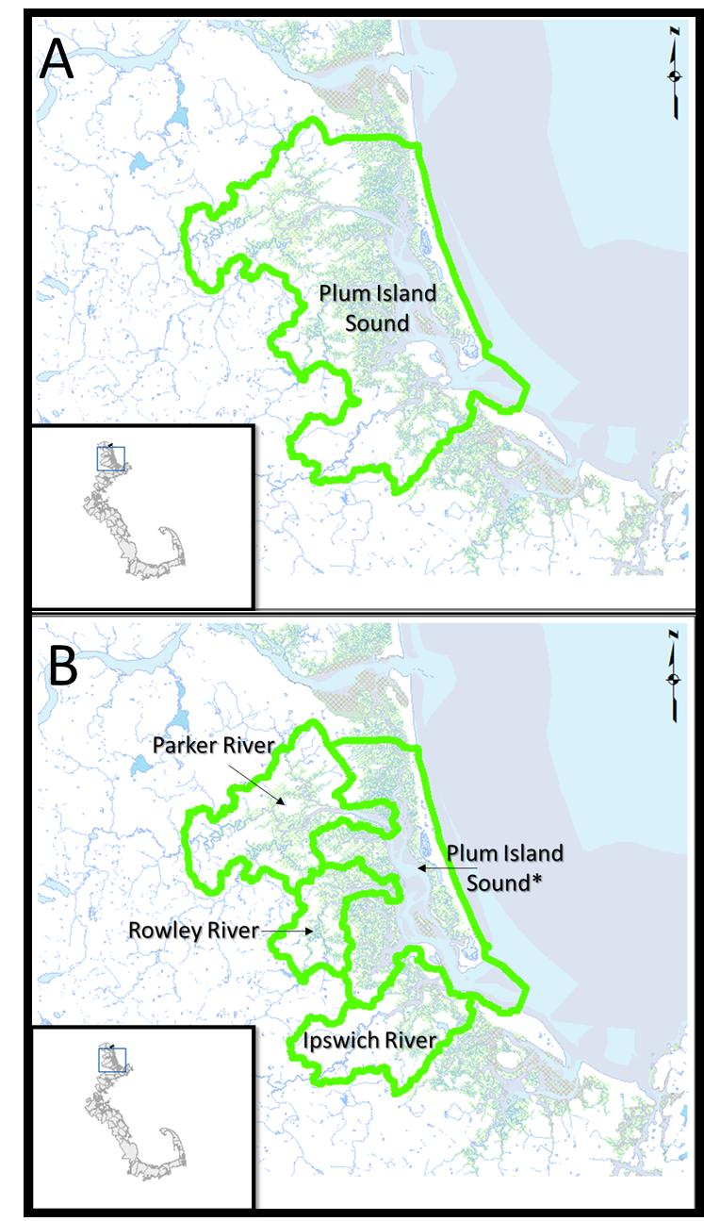

Figure 2. The boundaries of the aggregate Salem Sound embayment (A) encompassed other embayments (B & C) that were already included in the analyses. The Beverly Harbor (B) aggregate embayment was almost fully covered by the Danvers River embayment (C), with the only a small portion of open coastline missing. Hence, the Salem Sound and Beverly Harbor aggregate embayments were excluded from our analyses.

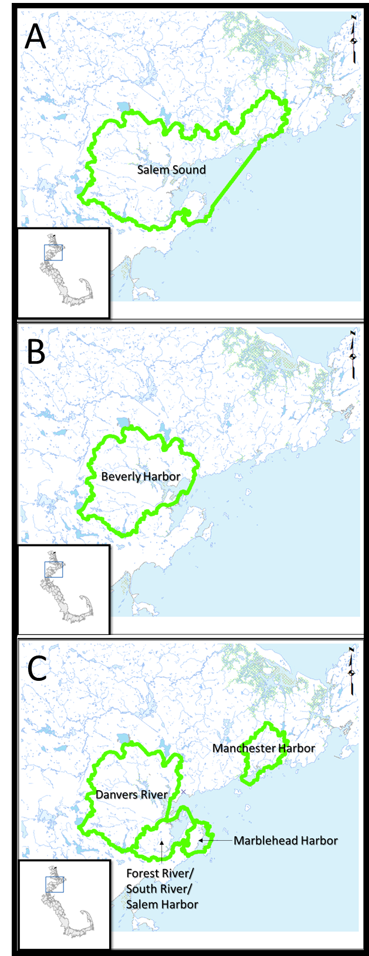

Figure 3. The boundaries of the aggregate Boston Harbor embayment (A) encompassed other embayments (B) that were already included in the analyses. Hence, the aggregate Boston Harbor embayment was excluded from our analyses.

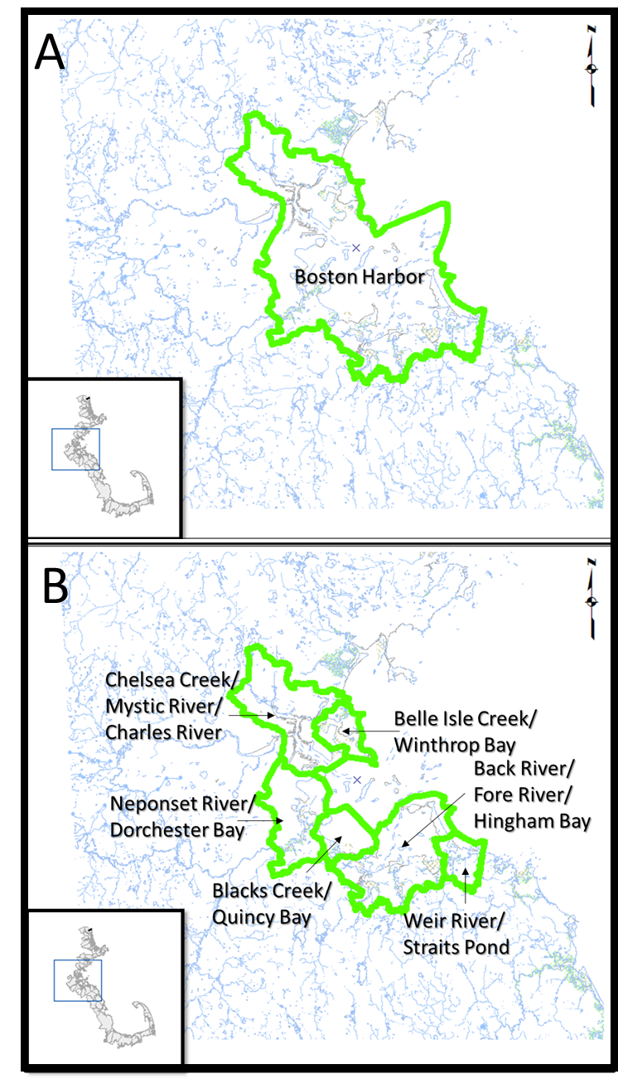

Selection of Environmental Parameters

A suite of environmental parameters associated with Massachusetts Embayment Program’s three management priorities were aggregated by Geosyntec, Inc. Environmental parameters were grouped into two categories: (1) environmental stressor attributes (Table 2A); and (2) estuarine resource attributes (Table 2B). Those categorized as stressor attributes were generally characteristics associated with impairments of an embayment, such as high intensity land use, 303(d) nutrient impairments, 303(d) bacterial impairments, and shoreline hardening. Those categorized as resource attributes were habitat features generally associated with more pristine embayments.

Geosyntec provided a list of 23 stressor and nine resource attributes (Tables 2A, B). Of the 23 stressors, 16 were completely removed from the analyses (see justifications in Table 2A). The remaining 7 were either used and unchanged or used and modified to create more ecologically meaningful metrics (Table 2A). We also created one new metric, Shoreline Hardened. Of the nine resource attributes, three were used, but adapted to more ecologically meaningful metrics (Table 2B). We also modified the salt marsh metric to create two more ecologically meaningful descriptions of salt marsh, explained below.

Salt marsh was originally provided as acres of salt marsh out of the total acres of the watershed. This metric does not reflect the area of land with the potential to be salt marsh, and hence could underestimate the importance of salt marshes. We therefore created two new metrics to describe salt marsh coverage: (1) the percent of shoreline that is suitable for saltmarsh that *is* saltmarsh (linear km salt marsh / km salt marsh suitable shoreline) and (2) areal extent of salt marsh (acres of salt marsh / km salt marsh shoreline).

Table 2. Original stressors (A) and resources (B) provided by Geosyntec. Tables show whether attributes were used without being changed, used after being modified, or not used and also provide justification for the inclusion, exclusion, or need for modification of each attribute. One additional stressor—shoreline hardened—was added to our analyses; see Table 3A for description.

A)



Table 2B)

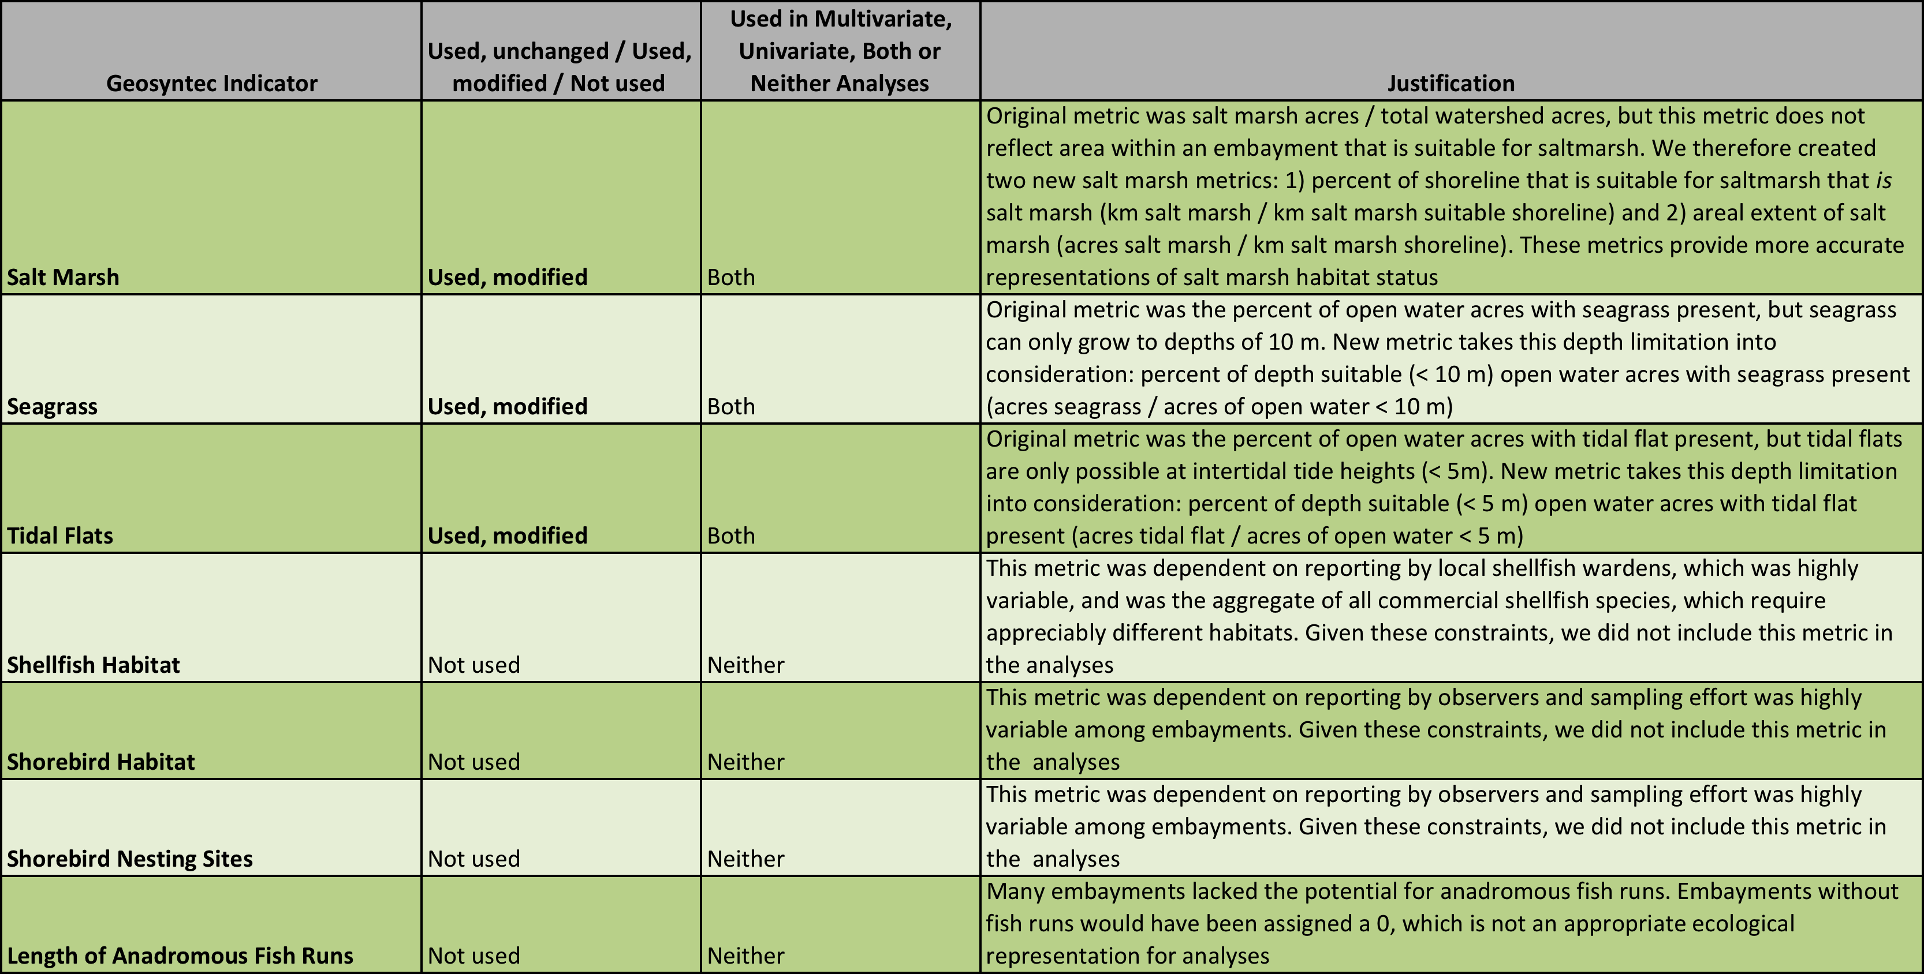

Attribute descriptions, data source, and rationale (adapted from Geosyntec’s *Massachusetts Bays Program Estuary Delineation and Assessment* report):

‘*Metric calculation*’ denotes how the metrics that were used in the multivariate and univariate analyses were calculated.

*Stressor attributes*

**Shoreline hardened:** Shoreline hardening is the practice of installing man-made structures along the shoreline in order to provide one or more of the following services: (1) stabilize sediment, (2) reduce erosion, or (3) protection from flooding. While shoreline hardening may provide temporary benefits to the communities living landward of armoring structures, engineered shorelines are associated with lower biodiversity and organismal abundances than natural shorelines (Gittman et al. 2016). They also reflect energy that can increase erosion rates of adjacent intertidal and subtidal habitats.

Data for shoreline hardening was obtained from the NOAA Environmental Sensitivity Index (ESI) shoreline type dataset. Shorelines were categorized as one of 15 major shoreline types, which we further narrowed to three categories: (1) hardened, (2) natural and with the potential to be hardened, or (3) natural but not suitable for hardening. ESI codes for these three categories are as follows: (1) hardened ESI codes: 1B, 6B, 6D, 8B, 8C, (2) natural and with the potential to be hardened ESI codes: 3A, 4, 5, 6A, 7, 8E, 8F, 9A, 9B, 9C, 10A, 10B, 10C, 10D, 10E, and (3) natural but not suitable for hardening ESI codes: 1A, 1C, 2A, 2B, 3B, 8A, 8D. Briefly, any engineered shorelines, such as riprap structures and seawalls, were categorized as hardened. Soft-sediment shorelines, both with and without vegetation, such as salt marshes and beaches, were categorized as natural but with the potential to be hardened. Hard substrate shorelines, such as rocky shores and rock platforms, were categorized as natural but not suitable for hardening.

*Metric calculation:* total linear kilometers of shoreline that was hardened was divided by the sum of shoreline that was hardened and shoreline with the potential to be hardened. This provided a metric of the percentage of shoreline that was hardened that had the potential to be hardened, which is a more accurate attribute of the effects of shoreline hardening along Massachusetts coastlines.

**High Intensity Land Use**: High intensity land use includes all residential, commercial, industrial, agricultural, and transportation related areas as delineated in the 2005 Massachusetts Land Use dataset. These types of anthropogenic land uses often lead to high rates of stormwater runoff, bacterial and nutrient contamination, and other types of non-point-source pollution. This attribute is related to other ecological stressors, such as road crossings and restrictions (due to the increased presence of roads in these land use areas), encroachment upon wetlands, and an increased presence of wastewater discharges.

*Metric calculation:* acres high intensity land use divided by the total acres in the embayment.

**Annual Stormwater Discharge**: Annual stormwater discharge is closely related to an increased load of bacterial and nutrient contamination to the receiving estuary. High rates of stormwater runoff can lead to increased transport of silt, sediment, and nutrients (especially from agricultural and residential areas), and bacteria (especially from highly developed, impervious areas). In some cases, stormwater runoff can have an effect on the frequency of combined sewer overflows, a significant source of bacterial and nutrient contamination. The rate of stormwater runoff is determined by several factors, including land use type, soil hydrologic group, and rainfall amount. Geosyntec utilized the NRCS Curve Number method and 50 years of local rainfall statistics to estimate the annual volume of stormwater discharge in each estuary.

*Metric calculation:* acre-ft stormwater / acres open water / year.

**Population density**: Population and population density are direct attributes of the extent of anthropogenic influence on an estuarine watershed. Increased population is an attribute of the presence of high intensity residential and commercial land uses as well as impervious area. These factors can lead to significant increases in stormwater runoff. High-population areas can lead to increased rates of wastewater discharge, either in the form of wastewater treatment plants or septic system use. Population was determined using 2010 US Census data.

*Metric calculation:* Number of people divided by the total acres in the embayment.

**Percent of population using septic systems/septic system use**: Septic systems can cause significant impacts to estuarine eutrophication via transport of nitrogen, a limiting nutrient in saline environments, from septic systems into the groundwater. A specific estimate of the presence of septic systems within a given estuarine watershed would require significant documentation of installation and pumping records available at various town board of health offices, an effort which is beyond the scope of this project. Instead, towns were surveyed by MBP regarding whether there was no, some, or total use of septic systems for onsite wastewater treatment. We calculated two metrics for septic system use: percent of the population using septic systems and septic system use.

*Metric calculation:* **Percent of population using septic systems**: number of people using septic divided by the total population; **septic system use**: number of people using septic systems divided by embayment land acreage.

**Impairments for nutrients 303(d)**:303(d) impairments indicate existing stress on the ecological capabilities of rivers, streams, lakes, and estuaries. MassDEP provides spatial representation of its 2010 303(d) list of impairments in two ways: linear representation for rivers and streams, and areal representation for lakes and estuaries. A water body listed as impaired for “Ammonia,” “Phosphorus,” “Chlorophyll-a,” “Excess Algal Growth,” or “Nutrient/Eutrophication Biological Attributes” was considered to be impaired with respect to nutrients. Nutrient impairments were considered in aggregate and not reported based on the individual nutrient category. We analyzed only the Estuary impairment data because a large number of data points were missing in the Tributary impairment data.

*Metric calculation:* acres of impaired water divided by the acres of open water.

**Impairments for bacteria 303(d)**:303(d) impairments indicate existing stress on the ecological capabilities of rivers, streams, lakes, and estuaries. MassDEP provides spatial representation of its 2010 303(d) list of impairments in two ways: linear representation for rivers and streams, and areal representation for lakes and estuaries. A water body listed as impaired for “Fecal Coliform” was considered to be impaired with respect to bacteria. We analyzed only the Estuary impairment data because a large number of data points were missing in the Tributary impairment data.

*Metric calculation:* acres of impaired water divided by the acres of open water.

**Conservation Assessment and Prioritization Systems (CAPS) tidal restriction**: Tidal restriction can adversely affect the ability of a system to support ecological processes and result in loss of system biodiversity. University of Massachusetts Amherst CAPS tidal restrictions data, an integrated dataset derived from MassGIS land use, stream centerlines, and roads/railroads as well as DEP wetlands and NOAA tide station data, were used to determine the amount of tidally restricted saltmarsh out of the entire saltmarsh present in a watershed (%).

*Metric calculation:* acres of salt marsh that are tidally restricted divided by the total acres of salt marsh.

*Resource attributes*

**Salt marsh**:Salt marshes are one of the critical resources being targeted by MBP’s management efforts. Salt marshes provide important water quality benefits via filtering of upstream waters, as well as habitat for shorebirds, crustaceans, and other biota. Salt marshes have been impacted by pollution, encroachment, filling, and restriction of normal tidal flushing. The extent of salt marsh was quantified using the MassDEP wetlands data layer.

*Metric calculations:* **salt marsh shoreline**: linear kilometers of shoreline with salt marsh present divided by linear kilometers of shoreline with the potential to be salt marsh; **salt marsh extent**: acres of salt marsh present in an embayment divided by the linear kilometers of shoreline with salt marsh present.

**Seagrass:** Seagrass (*Zostera marina*) is an important aquatic plant that provides key habitat and food for ecologically and commercially important fish and crustaceans. Seagrass beds have historically been degraded due to the light-limiting effect of increased turbidity and eutrophication.

MassDEP has mapped seagrass extent for years 1995, 2001, and 2006 using a combination of aerial imagery analysis and field confirmation. These datasets were used to determine an average extent of seagrass within each estuary over the decade-long period. MassGIS bathymetry layer was used to identify the embayment water area with a depth of <10 m because areas deeper than 10 m are largely unsuitable for seagrasses.

*Metric calculation:* acres of seagrass divided by the acres of open water that are less than 10 meters in depth.

**Tidal flats**: Tidal flats are estuarine habitat areas that are periodically exposed to air at low tide. They are important habitat for invertebrates and crustaceans that serve as food for many species of fish and shorebirds. The extent of tidal flats was quantified using the MassDEP wetlands data layer. Areas deeper than 5 m are too deep for tidal flats.

*Metric calculation:* acres of tidal flat divided by the acres of open water that are less than 5 meters in depth.

Table 3. Stressors (A) and resources (B) used in the multivariate and univariate analyses, along with the metric used, the source of the data, and details describing the attribute.

A)



Table 3B)

Analyses

For our multivariate analyses, we aggregated stressor and resource attributes of each embayment into a single dataset. We used principle component analysis (PCA), a Euclidean-based ordination method, to analyze our community data. Briefly, PCA is appropriate for variables that may or may not be correlated. The analysis collapses a larger number of variables into fewer, aggregated variables called ‘components’. A PCA then groups the data (in this case, embayments) together into ‘clusters’ according to their dissimilarity between the components. Embayments that are more dissimilar in their stressor and resource metrics are unlikely to be grouped into the same cluster.

Euclidean distance methods such as PCA are highly useful for community analyses when there are a large number of variables, but can experience problems when the included variables are not unimodally distributed. This issue can be rectified with appropriate data transformations. We applied a Hellinger transformation, one of the most commonly used for community data, to these data using the *decostand* procedure from the *vegan* package in R statistical analysis software (Oksanen *et al.*, 2013). The Hellinger transformation divides each value in a data matrix by the square root of its marginal sum of squares.

Following the transformation, we implemented a partitioning around mediods (PAM) approach using *pamk* procedure from the *fpc* package in R, to determine the appropriate number of clusters based on optimum average silhouette width (Hennig, 2013). A mediod is defined as a cluster and the surrounding space with minimal average dissimilarity to all objects in the cluster. We then conducted a principle components analysis (PCA) on the transformed data using the *princomp* procedure from package *stats*. Principle coordinate results were extracted and visualized graphically with PAM determined clusters differentiated by color (Fig. 4). We determined the appropriate number of components to include by visually inspecting the scree plot (e.g., the percentage of variance explained by each component) for a dropoff in explained variance.

We considered conducting a multivariate analysis that implemented a community ordination, environmental vector approach (non-metric dimensional scaling, NMDS) instead of a PCA. This type of analysis, however, requires that there be ‘predictor’ variables and ‘response’ variables, and that the response variables should be predictable by the predictor variables. Because we could not reasonably assign correlations between the stressor and resource attributes, we deemed this method inappropriate.

Next, we conducted a similarity percentages (SIMPER) analysis to determine the contribution of each variable (stressor and resource attributes) to the observed dissimilarity between clusters. SIMPER finds the average value of each stressor and resource metric for each PCA cluster and conducts pairwise comparisons between clusters for each stressor and resource. If the means in a given pairwise comparison were significantly different (at α = 0.05), then the variable being compared differed between the two clusters. We used a Bray-Curtis method on Hellinger transformed data. SIMPER analysis was conducted using the *simper* procedure from the *vegan* package (Oksanen *et al.*, 2013). See Tables 8-11. All of our analyses were conducted in R (v. 3.4.3, R Core Team, 2016).

*Objective 2. Identify target conditions for each embayment cluster*

We used regression tree analysis to evaluate which continuous stressor attributes were the most powerful predictors of select resource attributes. Univariate regression tree analysis explains variation in a response variable (here, resource attributes) using a select suite of explanatory variables (here, stressor attributes) by repeatedly partitioning data into increasingly homogeneous groups and maximizing homogeneity within and heterogeneity between the resulting subgroups (De'ath & Fabricius, 2000). We explored the effect of the nine stressor attributes used in the PCA (shoreline hardened, high intensity land use, population density, annual stormwater discharge, percent of population using septic systems, septic system use, impairment for nutrients, impairment for bacteria and CAPS tidal restriction) on the four resource attributes: salt marsh shoreline, salt marsh extent, seagrass, and tidal flats.

Regression trees have advantages over conventional statistical approaches including: (i) there are no assumptions regarding the statistical distribution of dependent and independent variable, (ii) they are not sensitive to multi-colinearity, outliers, heteroskedasticity or error structures that can confound parametric methods, and (iii) they can describe variable interactions. Regression trees are grown using a recursive partitioning method to search through alternative predictor variables in an effort to maximize the quality of the splits. Recursive partitioning is applied to each node until terminal nodes satisfy some optimality criterion. To avoid overfitting, trees are subsequently “pruned” to the optimum number of splits using one of a number of cross-validation approaches.

Cross-validation estimates the predicted error for a group of potential trees with different numbers of splits made from the same data. The optimally fitted tree has the lowest cross-validation predicted error. One disadvantage of tree-based methods is cutpoint selection instability, which can result in the formation of different trees based on the same data. Instability is often an issue in small datasets and can result in slightly different optimal tree sizes each time the model is run. Cross-validation creates new training sets (i.e., subsets of the full dataset) using a random number generator to select subset groupings. These training sets are used to examine the amount of variance explained by each split across multiple replicate trees. Due to the use of a random number generator, subset grouping varies each time the analysis is rerun and, as a result, so too can the optimum number of splits predicted by cross-validation. Although bootstrapping approaches such as *randomForest* are less susceptible to instability, they are more challenging to interpret. As a result, we elected to use non-bootstrapped trees and, in cases where instability was detected, to apply some subjective decision to decide to the number of reasonable splits. Regression tree analyses were conducted using the *rpart* procedure from package *rpart* in R.

Because regression trees provide threshold values of the stressor parameters that are most powerful in predicting each resource parameter, the results of our regression trees, coupled with the cluster results in Objective 1 where we define the range of each stressor and resource attribute for each cluster, provide the basis for our target recommendations in Objective 2. Depending on the resource attribute of interest (e.g., seagrass extent), the regression tree results and accompanying cluster tables can be used 1) set realistic targets for habitat coverage (i.e., within the range of its cluster), 2) determine the stressors that are most important in driving the health of the particular resource, and 3) define optimal or target stressor levels that correspond with greater resource quantity.

**Results**

*Objective 1. Characterize, compare, and cluster MassBays embayments*

The results of the multidimensional PCA are illustrated as an ordination diagram (Fig. 4). The first two axes in the PCA cumulatively explain 63.6% of the total variation in embayment characteristics, with axes 1 and 2 explaining 45.3% and 18.3% of the total variation, respectively. Axis 3 explained an additional 11.2% of total variance. As total variance explained by axes 4 and 5 was relatively low, 8.5% and 5.9% respectively, they were not considered relevant to our interpretation. Positive axis 1 values were largely explained by the percent of population using septic systems, salt marsh shoreline, salt marsh extent and tidal flats (Table 4). Negative axis 1 values were largely explained by the stressor attributes: shoreline hardened, high intensity land use, impairment for bacteria and CAPS tidal restriction (Table 4). Positive axis 2 values were largely explained by the positive values of CAPS tidal restriction, salt marsh shoreline, and tidal flats, while negative axis 2 values corresponded with higher values of shoreline hardened, percent of population using septic, and seagrass (Table 4). In axis 3, positive values indicated higher levels of tidal flats, salt marsh extent, shoreline hardened, high intensity land use, and population density (Table 4). Negative axis 3 values corresponded with greater levels of impairment for bacteria, CAPS tidal restriction, percent of population on septic, salt marsh shoreline, and seagrass (Table 4).

We found four separate clusters based on partitioning around mediods (Tables 5 and 6). SIMPER analysis indicated that difference between cluster means (Table 7) were in some cases driven by a single stressor or resource attribute, and in other cases were driven by a suite of attributes (Tables 8-11).

Mean shoreline hardened was higher for embayments in Cluster 2 and Cluster 4 than for Cluster 1 or Cluster 3 (Table 7). Mean shoreline hardened was significantly higher for Clusters 2 and 4 than for Clusters 1 and 3 (SIMPER analyses p <0.05; Tables 8-11). Mean high intensity land use was highest for the Cluster 4 embayments (Table 7), but only Clusters 3 and 4 significantly differed from each other (SIMPER analyses; Tables 8-11). No significant differences were detected between clusters for annual stormwater discharge (Tables 8-11). Mean population density was higher for embayments in Cluster 4 than for Clusters 1 or 3, but Clusters 2 and 4 did not significantly differ from each other.

The percentage of population using septic systems and septic system use (persons using septic per acre) were significantly higher for embayments in Clusters 1 and 3 than for Cluster 4 (Tables 8-11). Difference in mean percentage of population using septic systems between Cluster 2 and 4 were only marginally significant (Tables 8-11). No significant differences in mean impairment for nutrients were detected among clusters (Tables 8-11). Mean impairment for bacteria was universally high (e.g., > 90% of estuarine stations reporting impairment for bacteria) for embayment Clusters 2, 3 and 4 (Table 7), all of which were significantly higher mean impairment for bacteria than Cluster 1 embayments (Tables 8-11). Mean CAPS tidal restriction was highest for embayments in 4 (Table 7), although not significantly greater than those in Cluster 3 (Tables 10-11). Mean CAPS tidal restriction was significantly greater for Cluster 4 embayments than Cluster 1 or 2 embayments (Tables 8-11).

Mean salt marsh shoreline was significantly greater for Cluster 1 than for Cluster 2, but did not differ significantly from Clusters 3 or 4 (Tables 8-11). Mean salt marsh shoreline was significantly lower for Cluster 2 embayments than all other clusters (Tables 8-11). Salt marsh extent was, on average, significantly higher for Cluster 1 embayments than those in Clusters 2 and 4 (Tables 8-11). Cluster 3, which has the second highest mean salt marsh extent, was not significantly different from any other embayment cluster for this metric. Mean seagrass (acres seagrass per acre open water) was significantly greater for Cluster 2 embayments than all other embayments (Tables 8-11). Finally, mean tidal flat area (area tidal flats out of open water < 5 m) was significantly greater for Cluster 1, which has the highest mean, than for Cluster 2, which had the lowest (Tables 8-11). Clusters 3 and 4, which had intermediate mean tidal flat values, did not differ from any other clusters (Tables 8-11).

Figure 4. Principle Component Analysis (PCA) split the 42 embayments into four clusters based on the combined stressor and resource data. Numbers correspond to bay numbers; see Tables 5 and 6.

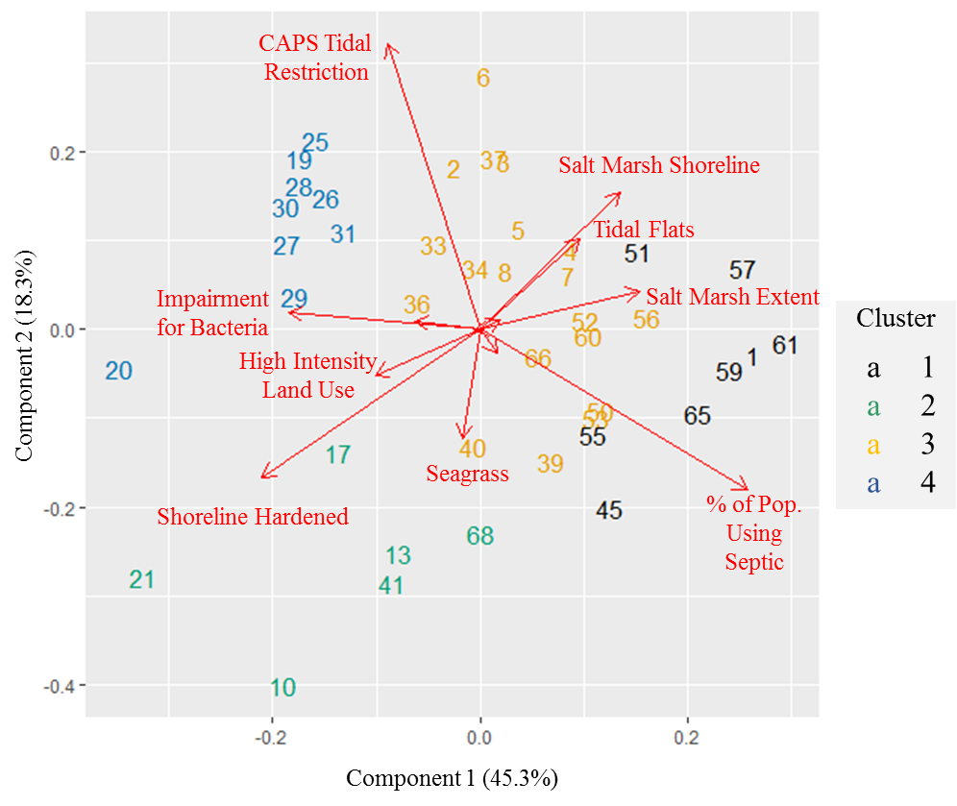

Table 4. Contribution of the nine stressor and four resource variables to the three components used in the PCA analysis. Bolded values (absolute value >0.1) represent a substantial contribution of that variable to that component. The sign of the value represents the direction of the contribution. Stressor variables are in red and resource variables are in green.



Table 5. Bay numbers, names, and assigned clusters based on PCA analysis, ordered by cluster. Colors correspond to cluster colors in Figure 4.



*As newly defined (excluding embayments 3-5)

Table 6. Bay numbers, names, and assigned clusters based on PCA analysis in Figure 4, ordered from North to South.



*As newly defined (excluding embayments 3-5)

Table 7. Means and ranges of the four clusters for the nine stressor and four resource factors considered in the PCA. For factor definitions and units, see Tables 3A and B. Stressor variables are in red and resource variables are in green.



Table 8. Results of SIMPER analysis based on the four PCA clusters. SIMPER conducts pairwise analysis to determine the contribution of embayment variables to the difference between clusters. Table contains p-values; numerical values represent significant differences (α = 0.05) between Cluster 1 and cluster listed in the column heading. ‘NS’ represents a non-significant p-value. Stressor variables are in red and resource variables are in green.



Table 9. Results of SIMPER analysis based on the four PCA clusters. SIMPER conducts pairwise analysis to determine the contribution of embayment variables to the difference between clusters. Table contains p-values; numerical values represent significant differences (α = 0.05) between Cluster 2 and cluster listed in the column heading. ‘NS’ represents a non-significant p-value. Stressor variables are in red and resource variables are in green.



Table 10. Results of SIMPER analysis based on the four PCA clusters. SIMPER conducts pairwise analysis to determine the contribution of embayment variables to the difference between clusters. Table contains p-values; numerical values represent significant differences (α = 0.05) between Cluster 3 and cluster listed in the column heading. ‘NS’ represents a non-significant p-value. Stressor variables are in red and resource variables are in green.



Table 11. Results of SIMPER analysis based on the four PCA clusters. SIMPER conducts pairwise analysis to determine the contribution of embayment variables to the difference between clusters. Table contains p-values; numerical values represent significant differences (α = 0.05) between Cluster 4 and cluster listed in the column heading. ‘NS’ represents a non-significant p-value. Stressor variables are in red and resource variables are in green.



*Objective 2. Identify target conditions for each embayment cluster*

Within each cluster, our analyses in Objective 1 defined a range and mean for each stressor and resource attribute (Table 7). The use of these in target setting is discussed below in the Discussion and Future Directions section. Furthermore, because each cluster is characterized by several resource and stressor attributes that are similar, some of these levels may be challenging to modify, and may not be linked in a causal fashion. Therefore, we used regression tree analysis to examine each resource attribute to determine the stressor attributes that are most predictive and to identify thresholds for these stressor attributes.

Regression tree analysis for salt marsh shoreline was unstable in its cross-validation estimate of the optimum number of splits, ranging from one to two. After rerunning the analysis multiple times, however, one split was the most frequently produced tree. Here, we present the tree with all splits, but recommend these results be interpreted cautiously given the instability in tree consistency. The full tree for salt marsh shoreline (% of suitable shoreline with salt marsh present) has three terminal nodes (Fig. 5). Shoreline hardened was the primary splitting factor. The node comprised of embayments with <19.8% shoreline hardened (n = 23, Table 12) had an average of 82.8% salt marsh shoreline (Fig. 5). The node comprised of embayments with ≥19.8% shoreline hardened (n = 19, Table 12) had an average of 54.5% salt marsh shoreline (Fig. 5). The node with lower shoreline hardened was further split by percentage of population using septic. Among embayments with <19.8% shoreline hardened, those with <71.6% of the population using septic systems had an average of 87.6% salt marsh shoreline, while those with ≥71.6% of the population using septic had, on average, 76.6% salt marsh shoreline (Fig. 5)

The optimum regression tree for salt marsh extent (acres of salt marsh per linear km salt marsh shoreline) had two significant splits, resulting in three terminal nodes. Population density was the primary splitting factor yielding two nodes (Fig. 6). The node with lower population density (<0.98 persons per acre) included embayments with, on average, 43.9 acres of salt marsh per km salt marsh shoreline (n = 18, Table 13). The higher population density node (≥0.98 persons per acre) had, on average, 17.7 acres of salt marsh per km salt marsh shoreline (n = 24, Table 13). This higher population density node was further split based upon shoreline hardening (Fig. 4). Within the node comprised of embayments with ≥0.98 persons per acre, embayments with <21.8% shoreline hardened had on average 25.5 acres of salt marsh per km salt marsh shoreline (n = 7, Table 13), while embayments with ≥21.8% shoreline hardened had on average 14.5 acres of salt marsh per km salt marsh shoreline (n = 17, Table 13).

Regression tree analysis for both seagrass and tidal flats yielded no significant splits.

Figure 5. Regression tree for salt marsh shoreline (percent of shoreline suitable for salt mash where salt marsh is present). Tree is significant to one split (see above explanation).

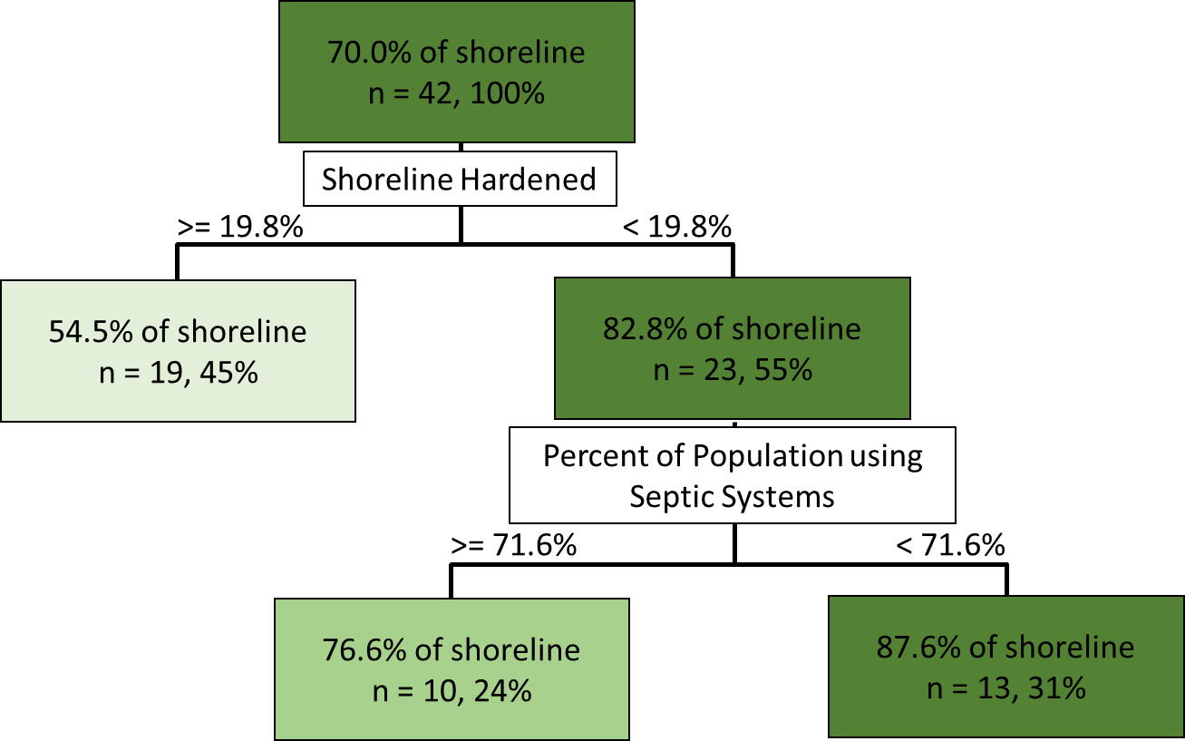

Table 12. List of bays sorted by their node grouping based on the regression tree for salt marsh shoreline (percent of shoreline suitable for salt mash where salt marsh is present) in Figure 5. The darker green area represents the terminal node with <19.8 shoreline hardened and the lighter shade of green is the terminal node with ≥19.8% shoreline hardened.



Figure 6: Regression tree for salt marsh extent (acres of salt marsh per linear km salt marsh shoreline). Tree is significant to two splits.

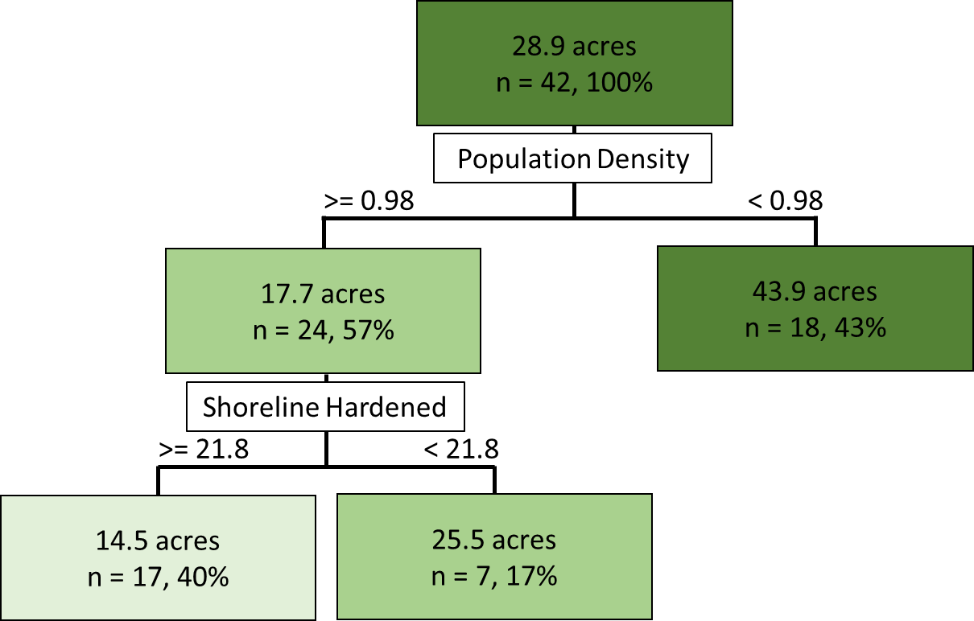

Table 13. List of bays sorted by their node grouping based on the regression tree for salt marsh extent (acres of salt marsh habitat per linear km salt marsh shoreline) in Figure 6. The darkest green area represents the terminal node with <0.98 people per acre. The intermediate shade of green is the terminal node with ≥0.98 people per acre and <17.3% shoreline hardened, and the lightest green is the terminal node with ≥0.98 people per acre and ≥17.3% shoreline hardened.



**Discussion & Future Directions**

While the cluster analyses revealed that embayment groups that are more proximal to each other had a higher likelihood of being in the same cluster, geography alone was a poor predictor of similarity in embayment characteristics (Figure 7). Although Cluster 4 was completely centered around the greater Boston area, an unsurprising finding given this region’s high population density and correspondingly high levels of anthropogenic stressors (Table 7), the other three clusters contained embayments throughout the MassBays NEP region. Moreover, our results support using stressor and resource attributes rather than geography alone to compare and set targets among similar embayments.

While it is likely a frequent occurrence for municipalities to compare themselves to neighboring municipalities, our multivariate approach reveals that this approach may be inherently problematic. Conversely, in clustering embayments based on quantitative stressor and resource attributes, local environmental regulators can compare the properties of their embayments with those that they are clustered with, and use them to set more achievable targets. For example, the embayments in Cluster 4 largely consist of urbanized environments with high amounts of shoreline hardening, high intensity land use, population density, and impairments from bacteria. Meanwhile, those embayments in Cluster 1 are predominately rural with low levels of shoreline hardening, high intensity land use, population density, and impairments for bacteria, but high levels of septic system use. Thus, just as it would likely be extremely challenging for those embayments in Cluster 4 to achieve the low levels of impairment for bacteria occurring in Cluster 1, realistic targets for those stressors that are high in Cluster 1 are fundamentally different from Cluster 4. Hence, comparisons within clusters will avoid the problems associated with comparisons made among highly different embayments that happen to be proximal to each other.

Our results provide insight into resource and attribute levels that may be achievable within a cluster. For example, our results provide a potential realistic target for the lower bounds of stressors and upper bounds of resources that might be able to be achieved for embayments within a given cluster. If a particular embayment has stressor values that are above the cluster mean, it may be experiencing greater anthropogenic impacts than other embayments with similar attributes, and thus reducing the stressor attribute could be the focus of local conservation efforts. When a particular stressor attribute is unable to be reduced, such as high intensity land use, efforts could focus on mitigating the potential impacts of this attribute as well as limiting further increases in it to the extent possible. Meanwhile, for resources, embayments with values below the cluster mean merit further investigation into the factors contributing to lower than average resource levels. For both salt marsh metrics, we have identified potential drivers of differences in salt marsh habitat among embayments in coastal Massachusetts.

While the range and mean of each cluster is provided, targets for critical stressor and resource attributes could be set at several different levels. For instance, the lower bound of the range is the current lowest level within a cluster, and likely is the minimum level achievable for each stressor attribute. Conversely, the same is true for the upper bound of each resource attribute within a cluster. For many stressor attributes, reducing levels to the lower bound within a cluster may be unrealistic given the range of competing demands within an embayment. While targets could be set using standard deviation(s) or confidence intervals beneath the mean for stressor attributes, the mean or median may be a more realistic target. While there are pros and cons of each of these approaches scientifically, stakeholder buy-in will be critical to achieving potential reductions in stressor levels. These same considerations are true for setting targets for resource attributes (i.e., whether to select somewhere near or at the upper bound vs. the median or mode). Given that several stressors may individually or interactively be contributing to declines in a resource attribute, achieving targets for resource metrics may be even more challenging.

Regression tree analyses revealed that levels of two of our four resource attributes (salt marsh shoreline and salt marsh extent) were best predicted by specific stressor attributes. Specifically, the amount of shoreline hardened was the greatest predictor of salt marsh shoreline habitat, which agrees with past studies suggesting that shoreline hardening degrades salt marsh habitat (Bozek and Burdick 2005, Gittman et al. 2016). In our study, embayments with >20% of hardened shoreline had just over half as much salt marsh shoreline habitat. Thus, this analysis suggests that 20% of hardened shoreline is a potential threshold, above which could result in the loss of salt marsh shoreline habitat. Meanwhile, for those embayments with <20% of hardened shoreline, the next most important predictor was the percentage of the population using septic systems. Embayments with > ~70% of their population using septic systems had 10% less salt marsh shoreline, suggesting another potential target threshold for these embayments.

Similar to salt marsh shoreline habitat, anthropogenic stressor attributes were strong predictors of salt marsh extent. Population density was the greatest predictor of salt marsh extent, with a breakpoint population of ~1 person per acre. Embayments that were above this threshold had less than half as much salt marsh habitat. Meanwhile, embayments with high population densities also varied as a function of shoreline hardening. Specifically, embayments with >~20% of shoreline hardening had 60% as much salt marsh habitat as those with <20% of shoreline hardening. Together with the results for salt marsh shoreline habitat, these results once again suggest that 20% of hardened shoreline is a critical threshold that could also be used as a target level by embayments aiming to reduce the potential impacts from this anthropogenic stressor.

Unlike salt marsh shoreline and salt marsh extent, regression tree analyses for the other two (tidal flat and sea grass habitat) resource attributes revealed no potential predictors of levels of either. The failure of regression tree analysis to identify critical thresholds of potential predictors could be a consequence of several factors. Seagrass habitat is harder to quantify and more ephemeral than salt marsh habitat. Furthermore, the stressor attributes that were able to be used in this study may not be the most important predictors of seagrass extent. For instance, turbidity and lack of light penetration have been associated with loss of seagrass habitat, but were not included in these analyses. Meanwhile, tidal flats are often not a limiting resource in estuarine systems, and can actually increase in extent when other critical habitats such as seagrass beds and oyster reefs are degraded (Grabowski et al. 2012). For both of these resource attributes, targets could still be set using the cluster results from Objective 1.

The stressor and resource data compiled by Geosyntec represents a comprehensive overview of metrics available through Massachusetts Ocean Resource Information System (MORIS). However, throughout the process of analyzing the data, we identified a number of metrics that could further refine future iterations of this assessment (Table 14). Some of these variables would enhance our understanding of potential stressor metrics already included in our analysis, such as levels of specific nutrients (e.g. phosphorous, ammonia), the volume of septic waste discharges, or the severity of tidal restriction within each embayment. Others, such as invasive species, subsidence, livestock density, levels of pollutants in waterways (e.g. halogenated hydrocarbons, polycyclic aromatic hydrocarbons, heavy metals), and bottom area dredged, represent novel metrics that could be valuable in better characterizing the suite of stressors facing each embayment. Inclusion of these different sets of stressor attributes could help identify potential predictors for resource attributes such as seagrass and tidal flat habitat. We have identified potential sources for the data that appear to be extant (Table 14), but suggest that the comprehensiveness of these data should be verified before inclusion.

In addition to including and modifying the above stressor metrics, future analyses would benefit from considering both additional resource attributes (Table 15) and from supplementing existing datasets with more robust sampling. For instance, shellfish habitat is known for providing a vast array of valuable ecosystem services, such as filtering the water and providing nursery grounds for juvenile fish and crustaceans (Grabowski et al. 2012). Kelp and rocky intertidal and subtidal habitat also are valued for the ecosystem services they provide. While these metrics were included in the Geosyntec 2.0 report, MORIS lacks comprehensive, reliable data delineating these habitats. Thus, efforts to characterize these resource attributes would be valuable to future MassBays assessments.

Table 14. Recommended stressors to include in future work and potential data sources.



Table 15. Recommended resources to include in future work and potential data sources.



Figure 7. Map of cluster grouping for the 42 embayments included in the multivariate (PCA) analysis.

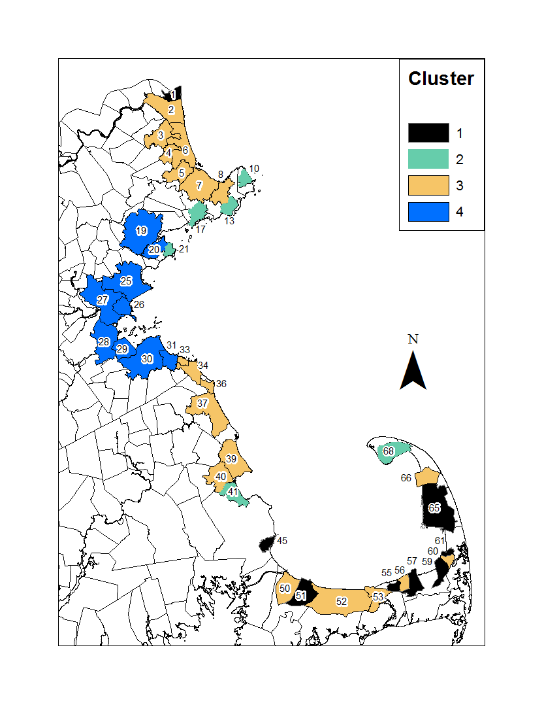

Figure 8. Map of shoreline hardened for the 42 embayments included in the multivariate (PCA) analysis.

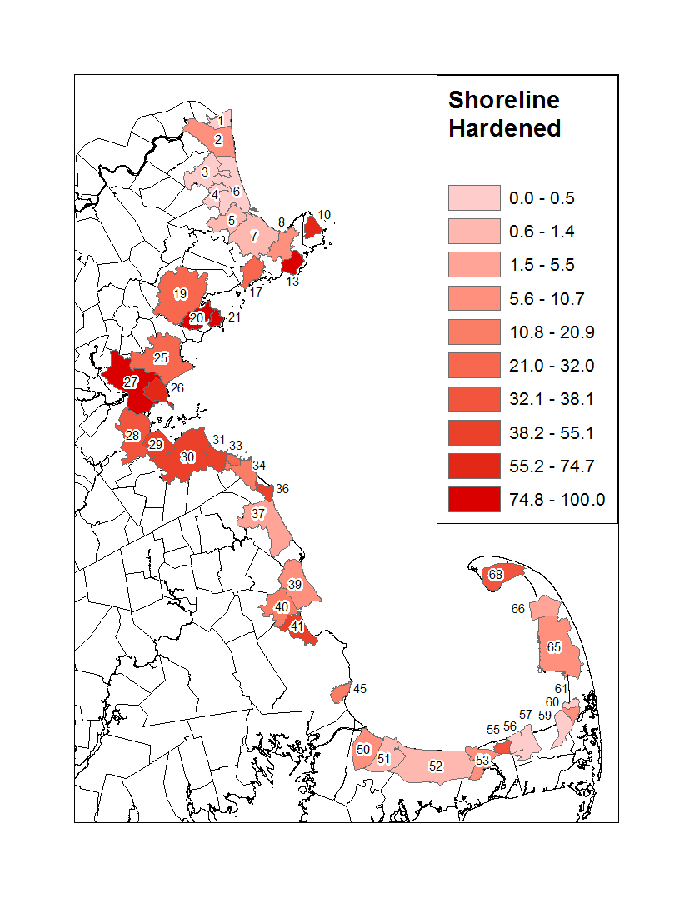

Figure 9. Map of high intensity land use for the 42 embayments included in the multivariate (PCA) analysis.

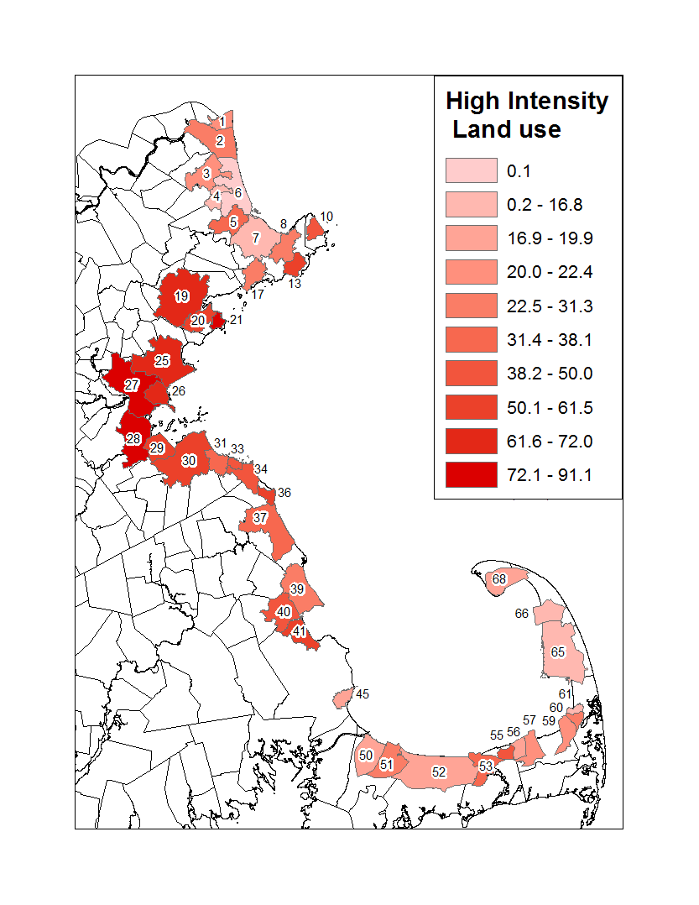

Figure 10. Map of annual stormwater discharge for the 42 embayments included in the multivariate (PCA) analysis.

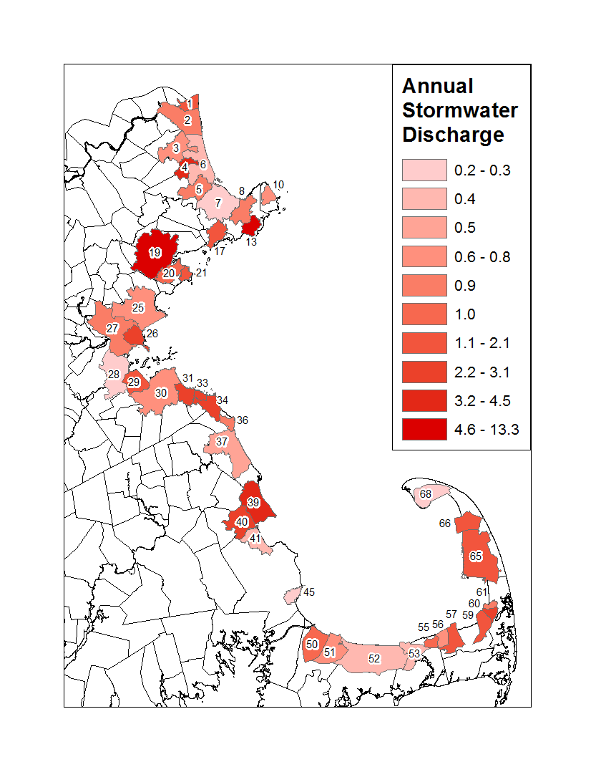

Figure 11. Map of population density for the 42 embayments included in the multivariate (PCA) analysis.

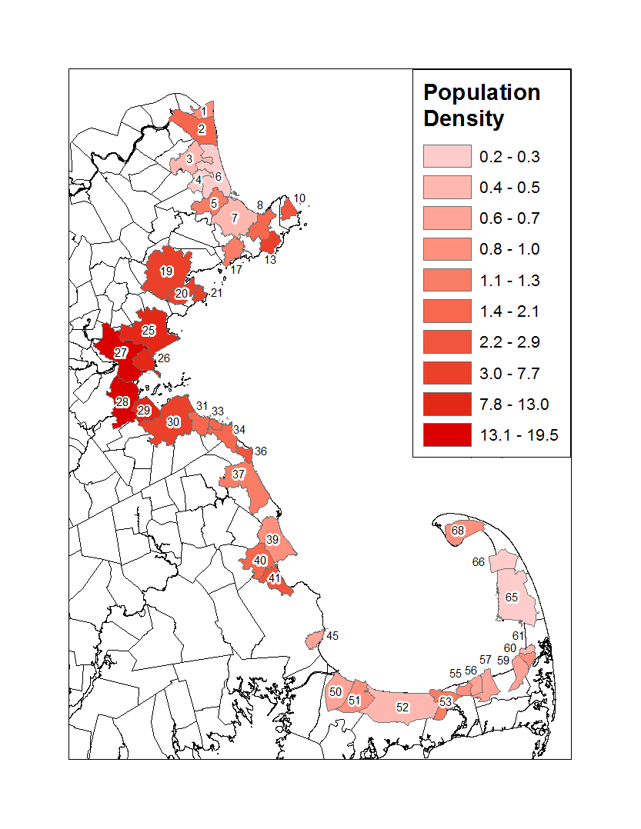

Figure 12. Map of percentage of population using septic systems for the 42 embayments included in the multivariate (PCA) analysis.

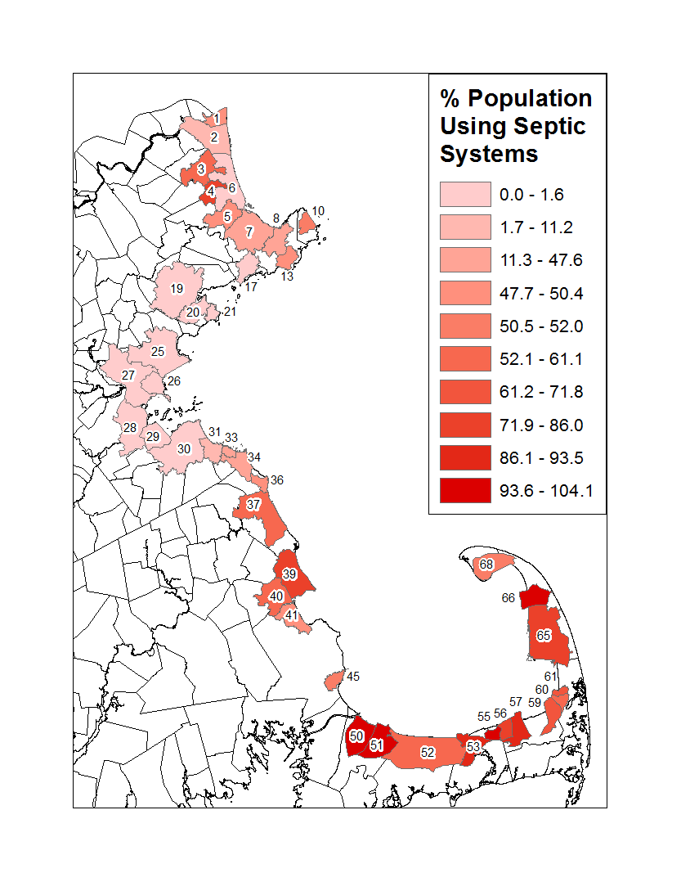

Figure 13. Map of septic systems use (persons/acre) for the 42 embayments included in the multivariate (PCA) analysis.

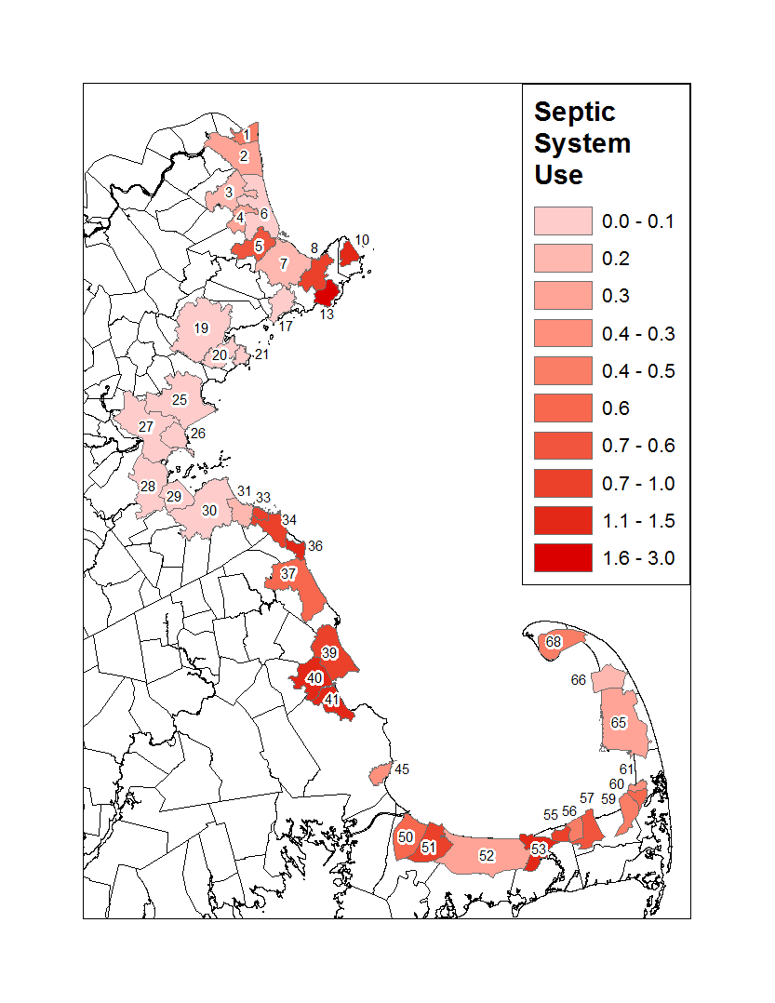

Figure 14. Map of impairment for nutrients for the 42 embayments included in the multivariate (PCA) analysis.

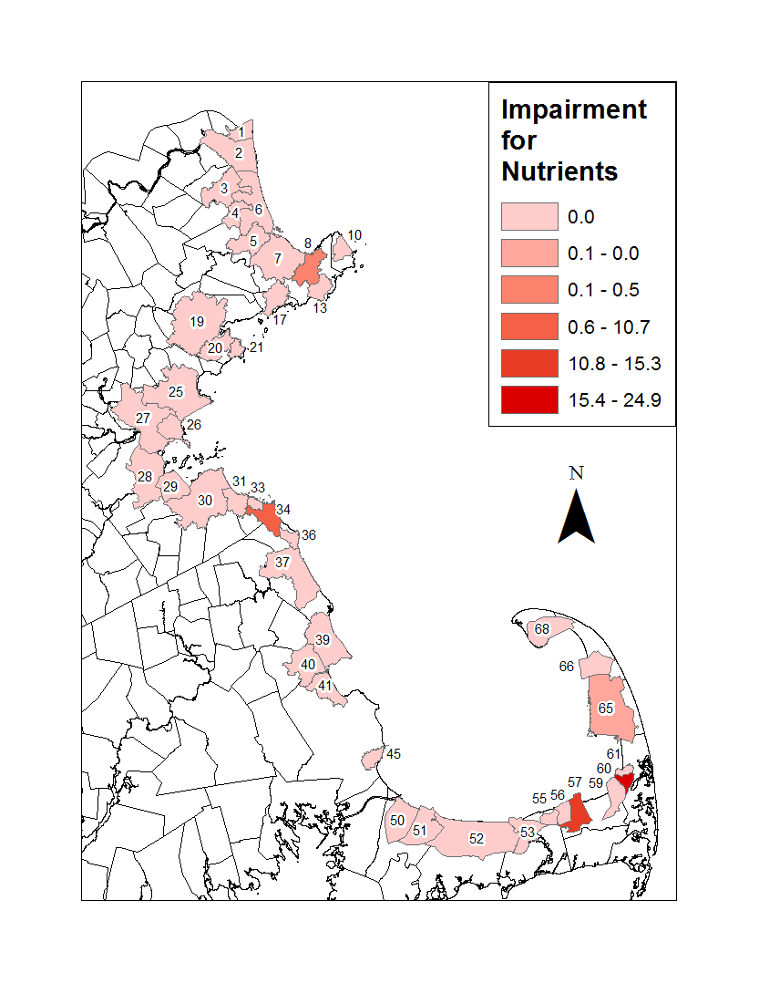

Figure 15. Map of impairment for bacteria for the 42 embayments included in the multivariate (PCA) analysis.

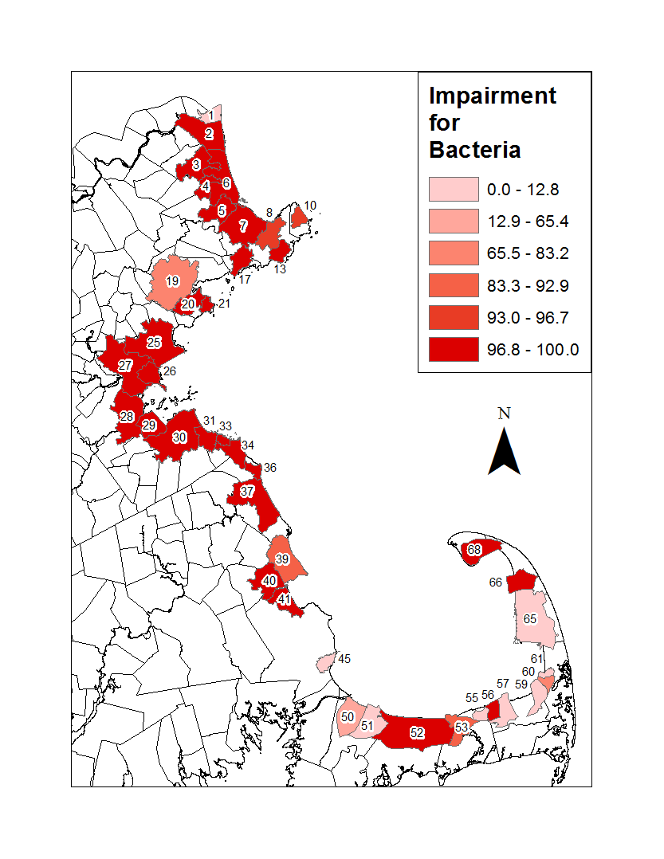

Figure 16. Map of impairment for CAPS tidal restriction salt marsh for the 42 embayments included in the multivariate (PCA) analysis.

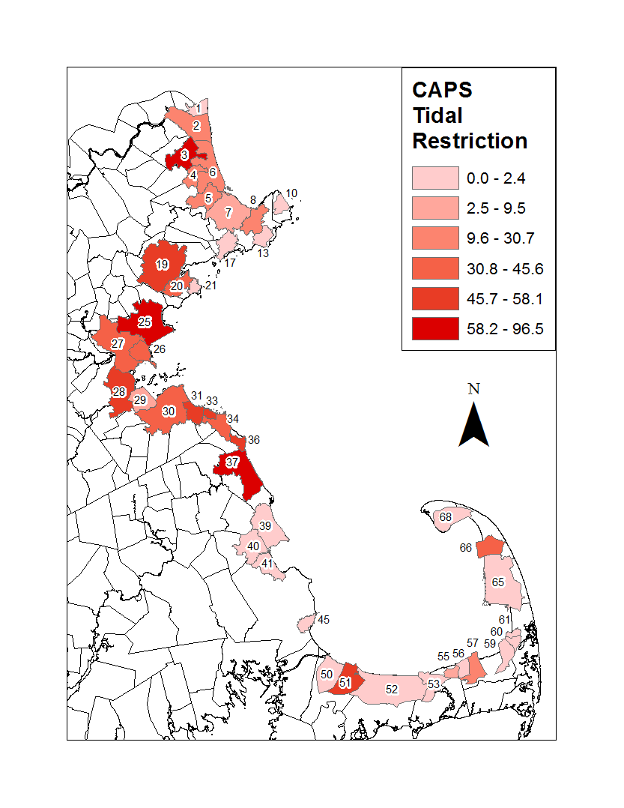

Figure 17. Map of salt marsh shoreline for the 42 embayments included in the multivariate (PCA) analysis.

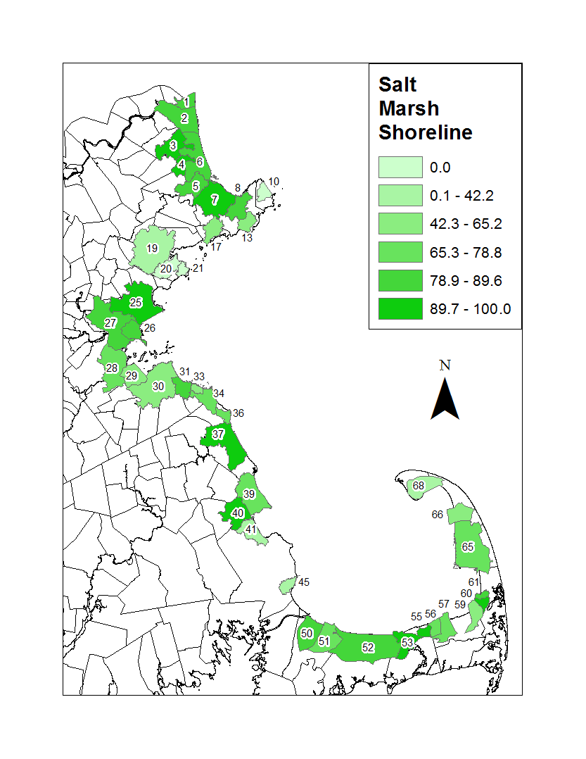

Figure 18. Map of salt marsh extent for the 42 embayments included in the multivariate (PCA) analysis.

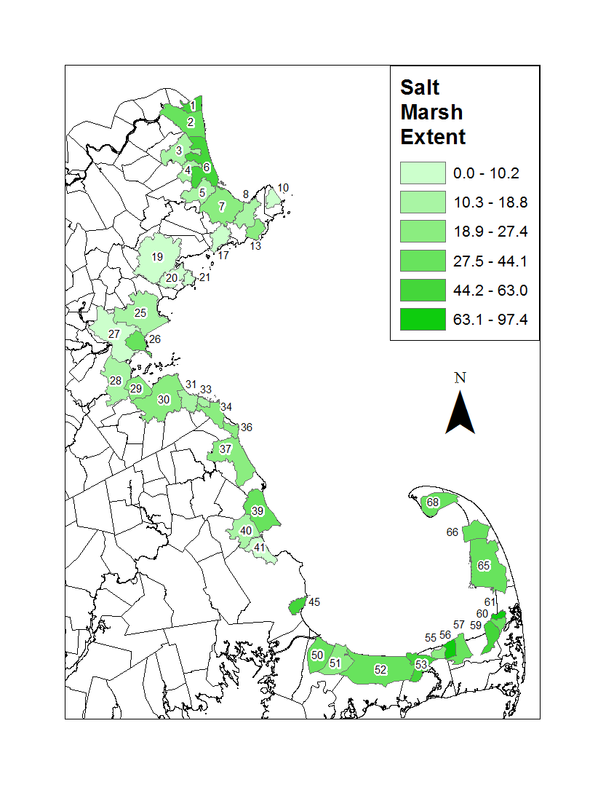

Figure 19. Map of seagrass for the 42 embayments included in the multivariate (PCA) analysis.

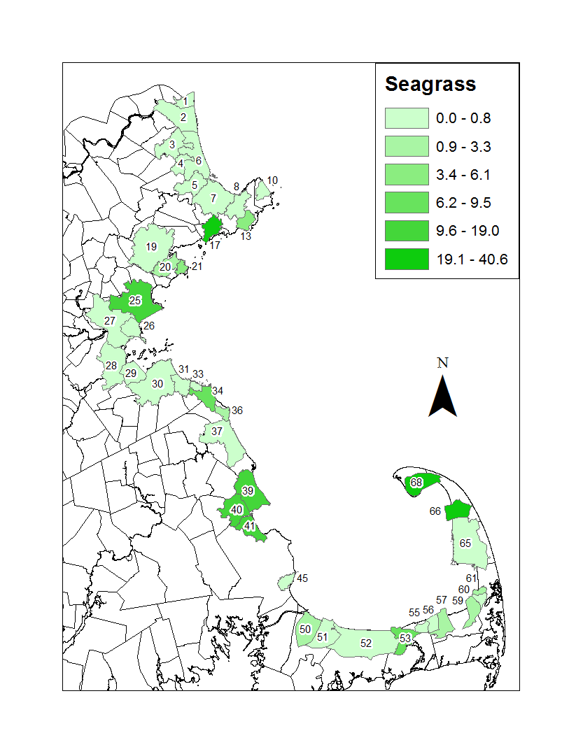////

Figure 20. Map of tidal flats for the 42 embayments included in the multivariate (PCA) analysis.

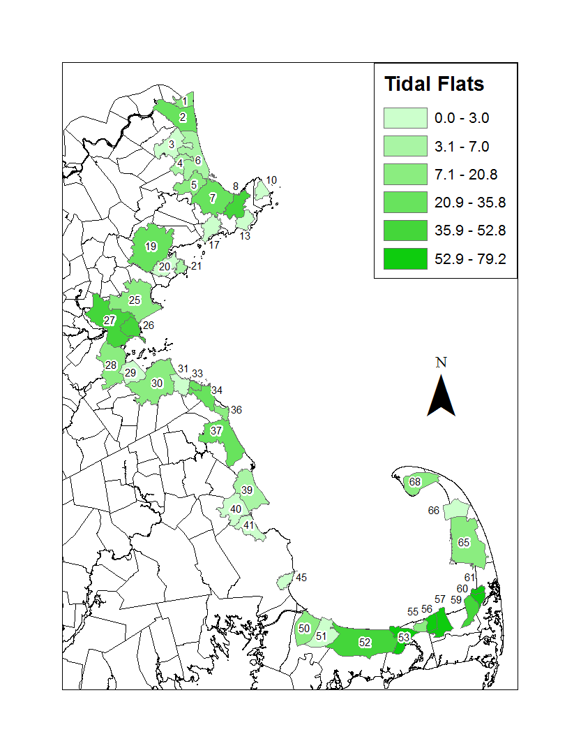

**References**

Airoldi, L. & Beck, M.W. (2007) Loss, status and trends for coastal marine habitats of Europe. *Oceanography and Marine Biology Annual Review*, **45**, 345-405.

Barbier, E.B., Hacker, S.D., Kennedy, C., Koch, E.W., Stier, A.C. & Silliman, B.R. (2011) The value of estuarine and coastal ecosystem services. *Ecological Monographs*, **81**, 169-193.

Beck, M.W., Heck, K.L., Able, K.W., Childers, D.L., Eggleston, D.B., Gillanders, B.M., Halpern, B.S., Hays, C.G., Hoshino, K., Minello, T.J., Orth, R.J., Sheridan, P.F. & Weinstein, M.P. (2001) The identification, conservation, and management of estuarine and marine nurseries for fish and invertebrates. *BioScience*, **51**, 633-641.

Beck, M.W., Brumbaugh, R.D., Airoldi, L., Carranza, A., Coen, L.D., Crawford, C., Defeo, O., Edgar, G., Hancock, B., Kay, M., Lenihan, H., Luckenbach, M., Toropova, C. & Zhang, G. (2011) Oyster reefs at risk and recommendations for conservation, restoration and management. *BioScience*, **61**, 107-116.

Bozek, C.M. & Burdick, D.M. (2005) Impacts of seawalls on saltmarsh plant communities in the Great Bay Estuary, New Hampshire USA. *Wetlands Ecology and Management*, **13**, 553-568.

Costanza, R., d'Arge, R., de Groot, R., Farber, S., Grasso, M., Hannon, B., Limburg, K., Naeem, S., O'Neill, R.V., Paruelo, J., Raskin, R.G., Sutton, P. & van den Belt, M. (1997) The value of the world's ecosystem services and natural capital. *Nature*, **387**, 253-260.

De'ath, G. & Fabricius, K.E. (2000) Classification and regression trees: a powerful yet simple technique for ecological data analysis. *Ecology*, **81**, 3178-3192.

Gittman, R.K., Scyphers, S.B., Smith, C.S., Neylan, I.P. & Grabowski, J.H. (2016) Ecological consequences of shoreline hardening: a meta-analysis. *BioScience*, **66**, 763-773,

Grabowski, J.H., Brumbaugh, R.D., Conrad, R., Keeler, A.G., Opaluch, J., Peterson, C.H., Piehler, M.F., Powers, S.P. & Smyth, A.R. (2012) Economic valuation of ecosystem services provided by oyster reefs. *BioScience*, **632**, 900-909.

Halpern, B.S., Walbridge, S., Selkoe, K.A., Kappel, C.V., Micheli, F., D'Agrosa, C., Bruno, J.F., Casey, K.S., Ebert, C., Fox, H.E., Fujita, R., Heinemann, D., Lenihan, H.S., Madin, E.M.P., Perry, M.T., Selig, E.R., Spalding, M., Steneck, R. & Watson, R. (2008) A global map of human impact on marine ecosystems. *Science*, **319**, 948-952.

Hennig, C. (2013) fpc: Flexible procedures for clustering. R package version 2.1-5.

Jackson, J.B.C., Kirby, M.X., Berger, W.H., Bjorndal, K.A., Botsford, L.W., Bourque, B.J., Bradbury, R.H., Cooke, R., Erlandson, J., Estes, J.A., Hughes, T.P., Kidwell, S., Lange, C.B., Lenihan, H.S., Pandolfi, J.M., Peterson, C.H., Steneck, R.S., Tegner, M.J. & Warner, R.R. (2001) Historical overfishing and the recent collapse of coastal ecosystems. *Science*, **293**, 629-638.

Kirby, M.X. (2004) Fishing down the coast: Historical expansion and collapse of oyster fisheries along continental margins. *Procedures of the National Academy of Science, USA*, **101**, 13096-13099.

Lotze, H.K., Lenihan, H.S., Bourque, B.J., Bradbury, R., Cooke, R.G., Kay, M.C., Kidwell, S.M., Kirby, M.X., Peterson, C.H. & Jackson, J.B.C. (2006) Depletion, degradation and recovery potential of estuaries and coastal seas. *Science*, **312**, 1806-1809.

Oksanen, J., Blanchet, F.G., Kindt, R., Legendre, P., Minchin, P.R., O’Hara, R., Simpson, G.L., Solymos, P., Stevens, M.H.H. & Wagner, H. (2013) Package ‘vegan’. *Community ecology package, version* **2**

Rothschild, B.J., Ault, J.S., Goulletquer, P. & Heral, M. (1994) Decline of the Chesapeake Bay oyster population: A century of habitat destruction and overfishing. *Marine Ecology Progress Series*, **111**, 29-39.

R Team (2015) A language and environment for statistical computing. Vienna, Austria. 2014.

Waycott, M., Duarte, C.M., Carruthers, T.J.B., Orth, R.J., Dennison, W.C., Olyarnik, S., Calladine, A., Fourqurean, J.W., Heck, K.L., Hughes, A.R., Kendrick, G.A., Kenworthy, W.J., Short, F.T. & Williams, S.L. (2009) Accelerating loss of seagrasses across the globe threatens coastal ecosystems. *Proceedings of the National Academy of Sciences of the United States of America*, **106**, 12377-12381.

Wilkinson, C. (2008) *Status of Coral Reefs of the World: 2008 Global Coral Reef Monitoring Network and Reef and Rainforest Research Center*, Townsville, Australia.